How to get started. This code is designed to run with a SQL server. This is to help design nice cool machine learning codes using more than just Matlab. The server also helps to make really useful datatables at the end of the run, instead of endless text dumps.

To set up the code, first download the free edition of mySQL. The setup is pretty simple and straigtforward. Use the MySQL workbench to run the script, “CreateDatabase.sql”, which is in the root directory. This will create the database with the correct structure.

The connection we are using is ODBC, as this seems to give the fastest data transfer rates. You must set up a named instance of the database connection. To do this click **Start Menu->Control Panel ->Admin Tools ->** **Data Sources (ODBC).** A form will show up that has **add** as the first option. Click add and this dialog will show up

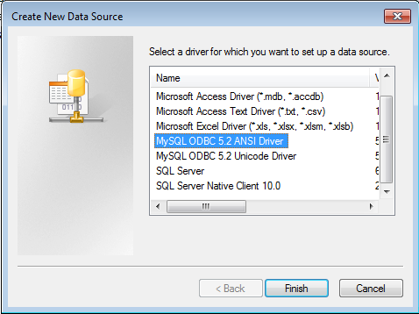

Chose the MySQL adapter. Then fill out the form with a similar setup to this:

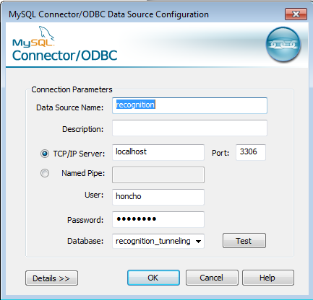

You should now have a working database connection for Matlab and the C# adapter.

The C# adapter may require you to compile the C# source. Use Mono or C# express for this task, both are free. Unfortunately, the database implementation in Matlab has a memory leak, so transferring the peak data from the database leads to memory errors. The C# code only transfers the data from the database to a table that Matlab likes.

Master.m is the starting file, and FlowThrough.xlsx is used as a very flexible and user friendly GUI for the settings.